Database CS 586

HomeWork-1

Q1

Answer:

Agent [agent_id, first, middle, last, address, city, country, salary, clearance_id ]

Clearance_id -> securityclearance (sc_id)

Skill[skill_id, skill]

Skillrel[skill_id, agent_id]

Skill_id -> skill(skill_id)

Agent_id -> agent(agent_id)

Affiliation [aff_id, agent_id, affiliation_strength]

Aff_id -> affiliation(aff_id)

Agent_id -> agent(agent_id)

Mission [mission_id, name, access_id, team_id, mission_status]

Access_id -> securityclearance(access_id)

Team_id -> team(team_id)

Securityclearance(sc_id, sc_level, description)

Q2

1. One
2. Many
3. Yes
4. Many
5. Yes

Q3

1. SELECT * FROM agent WHERE country = 'USA' and city ='Washington DC';

Here from the Table agent we have to find all agents whose country is USA and city is Washington DC;

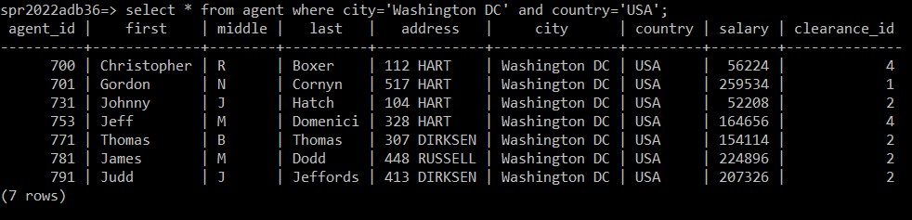

1. Select salary from agent;

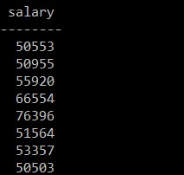

Total rows= 662

1. Select distinct clearance_id from agent;

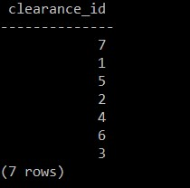

1. Select agent_id, city, country, clearance_id, from agent where salary>95000 and country!=’USA’;

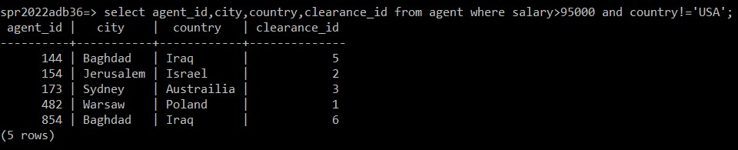

Q4

1. Select distinct country from agent where salary>100000;

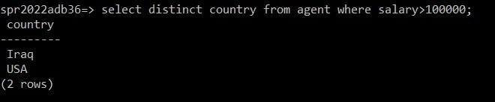

1. Select distinct county from agent where agent.salary > 100000;

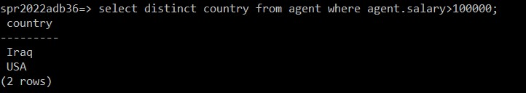

1. Select distinct country from agent A where A.salary > 100000;

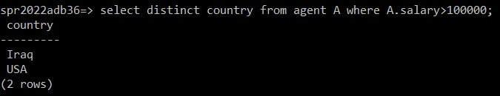

Q5 Select team_id,meeting_frequency from team where name =’Vikings’;

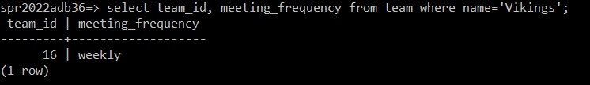

Q6 Select distinct A.country from agent A, securityclearance S where A.clearance_id= S.sc_id

And S.sc_level=”top secret” OR S.sc_level=’Majestic’;

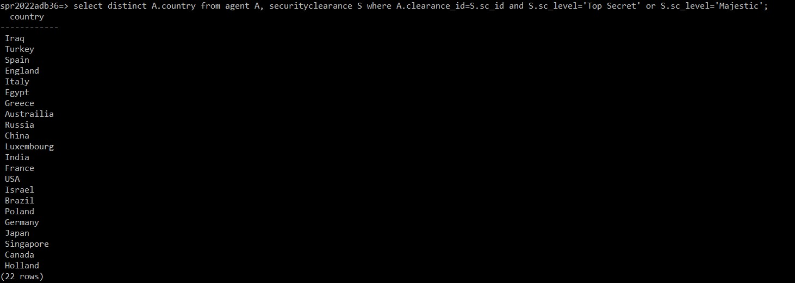

Q7 Create TempTable temp_affiliationrel as select * from affiliationrel;

Select distinct a.first, a.last, a.city From agent a, affiliationrel ar, temp_affiliationrel tar

Where a.agent_id =ar.agent and ar.aff_id != tar.aff_id;

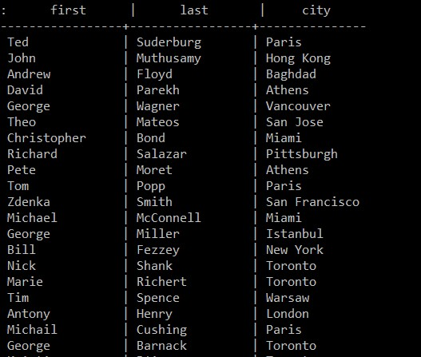

Total rows=502

Q8 Select Distinct m.name, m.mission_status From mission m, teamrel tr, skillrel sr, skill s

Where m.team_id=tr.team_id and tr.agent_id = sr.agent_id

And sr.skill_id =s.skill_id

And s.skill=’VooDoo/Blackmagic’:

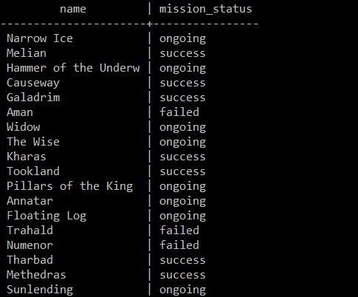

Total rows=180

Q9

Select distinct a.first, a.last from agent a, temp_agent ta where a.agent_id !=ta.agent_id

And a.first= ta.first and a.last=ta.last

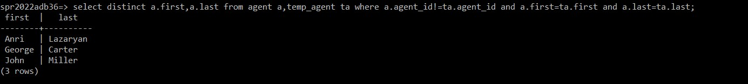

Q10